**College Database**

# Project Team (3 students)

|  |  |  |
| --- | --- | --- |
| **No** | Stu-Number | Name Surname |
| 1 | 17070001002 | Selin Çetiner |
| 2 | 17070001013 | Berkın Akbıyık |
| 3 |  |  |

**PHASE 2-Normalization and SQL Examples**

# Tables Design

* Fill the tables with at least 10 records (Any program you developed to fill the records automatically will bring additional points)
* Review the final design, and explain each functional dependencies one by one according to the tables
* Apply normalization rules (1NF,2NF,3NF)---All tables

## Admin

metin içeren bir resim

Açıklama otomatik olarak oluşturuldu

## Department

tablo içeren bir resim

Açıklama otomatik olarak oluşturuldu

## Faculty

metin içeren bir resim

Açıklama otomatik olarak oluşturuldu

## Grades

tablo içeren bir resim

Açıklama otomatik olarak oluşturuldu

## Lesson

metin, tablo içeren bir resim

Açıklama otomatik olarak oluşturuldu

## Student

tablo içeren bir resim

Açıklama otomatik olarak oluşturuldu

## Student_has_grades

tablo içeren bir resim

Açıklama otomatik olarak oluşturuldu

## Teacher

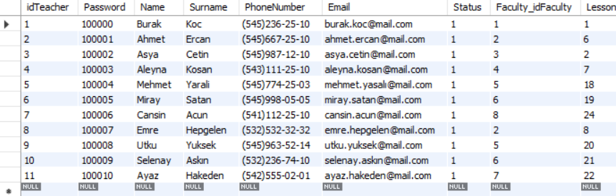

# Functional Dependencies

## Table 1 Name

## Table 2 Name

## Table 3 Name

## Table 4 Name

## Table x Name

## Table x Name

# Normalizations

Explain 1NF,2NF,3NF

## 1NF for all tables---Since you have already designed your tables according to this rule, ignore and just check again

Explain the 1NF status of your tables.

## 2NF for all tables

## 3NF for all tables

# SQL Examples

Show the syntaxes and give 2 examples for each

## SELECT ?

Select * from lesson;

Select stddev(quizGrade) from grades;

## DISTINCT ?

Select distinct name from student;

Select distinct hwgrade from grades;

## WHERE ?

Select id_faculty from faculty where department=Industrial Engineering;

Select name,surname from teacher where teacher_title IN(select max(teacher_title) from table ));

## AND/OR ?

Select surname from grades where (quizgrade=100) and (midtermgrade=70);

Select surname from grades where (finalgrade>75) or (hwgrade<70);

## BETWEEN

 Select* from grades where quizgrade between 10 and 20;

Select* from grades where finalgrade not between 25 and 85;

## ORDER BY ?

select name from teacher ORDER BY teacher_title asc;

select dept_id from lesson where title=5 ORDER BY Grade desc limit 5;

## GROUP BY?

Select count(name), class from student group by class;

Select count(Password), PhoneNumber from table group by PhoneNumber;